**Tables**

**Table 1.** Locations of migration monitoring stations and summary of data contributing data to continental analysis of Blackpoll Warbler population trends.

|  |  |  |  |  |  |  |  |  |  |
| --- | --- | --- | --- | --- | --- | --- | --- | --- | --- |
| Station code | Station name | Country | Lat | Lon | Year range | Mean annual count | Min annual count | Max annual count | Catchment Estimate Method |
| Pre-breeding ("spring") migration monitoring stations | | | | | | | | |  |
| ACBO | Albert Creek Bird Observatory | CAN | 60.1 | -128.9 | 2007 - 2018 | 80.1 | 21 | 169 | Fixed (west) |
| AIMS | Appledore Island Migration Station | USA | 43 | -70.6 | 2000 - 2018 | 66.4 | 31 | 128 | Fixed (east) |
| BSBO | Black Swamp Bird Observatory | USA | 41.6 | -83.2 | 2000 - 2018 | 75.7 | 20 | 176 | - |
| FBBO | Foreman's Branch Bird Observatory | USA | 39.2 | -76.1 | 2006 - 2018 | 8.2 | 0 | 21 | - |
| IPBO | Innis Point Bird Observatory | CAN | 45.4 | -75.9 | 2000 - 2018 | 23.4 | 5 | 52 | - |
| LMBO | Last Mountain Bird Observatory | CAN | 51.4 | -105.2 | 2000 - 2018 | 9.8 | 0 | 33 | Fixed (west) |
| LPBO | Long Point Bird Observatory | CAN | 42.6 | -80.3 | 2000 - 2018 | 266.8 | 68 | 577 | Isotopes |
| MCCS | Manomet Observatory | USA | 41.9 | -70.5 | 2000 - 2018 | 14 | 1 | 34 | Fixed (east) |
| MGBO | McGill Bird Observatory | CAN | 45.4 | -73.9 | 2006 - 2018 | 39.4 | 3 | 85 | Isotopes |
| PEPBO | Prince Edward Point Bird Observatory | CAN | 43.9 | -76.9 | 2000 - 2018 | 19.2 | 5 | 43 | Isotopes |
| PIBO | Pelee Island Bird Observatory | CAN | 41.7 | -82.7 | 2003 - 2018 | 15.4 | 1 | 35 | - |
| RUTH | Haldimand Bird Observatory - Ruthven | CAN | 42.6 | -79.5 | 2000 - 2018 | 22.7 | 3 | 70 | Isotopes |
| TTPBRS | Tommy Thompson Park Bird Research Station | CAN | 43.6 | -79.3 | 2005 - 2018 | 37.7 | 13 | 75 | - |
| Post-breeding ("fall") migration monitoring stations | | | | | | | | |  |
| BIBS | Block Island Banding Station | USA | 41.2 | -71.6 | 2000 - 2018 | 11.9 | 0 | 36 | - |
| BPBO | Bruce Peninsula Bird Observatory | CAN | 45.2 | -81.4 | 2002 - 2018 | 18.9 | 4 | 80 | - |
| BSBO | Black Swamp Bird Observatory | USA | 41.6 | -83.2 | 2000 - 2018 | 536.2 | 117 | 1129 | - |
| CFMS | Creamer’s Field Migration Station | USA | 64.9 | -147.7 | 2000 - 2018 | 25.9 | 1 | 57 | West only |
| FBBO | Foreman's Branch Bird Observatory | USA | 39.2 | -76.1 | 2006 - 2018 | 17.8 | 4 | 68 | - |
| KWRS | Kingston Wildlife Research Station | USA | 41.5 | -71.5 | 2000 - 2018 | 20 | 0 | 65 | Isotopes |
| LMBO | Last Mountain Bird Observatory | CAN | 51.4 | -105.2 | 2000 - 2017 | 54.8 | 0 | 124 | West only |
| LPBO | Long Point Bird Observatory | CAN | 42.6 | -80.3 | 2000 - 2018 | 2565.8 | 613 | 5000 | - |
| MCCS | Manomet Observatory | USA | 41.9 | -70.5 | 2000 - 2018 | 85.3 | 14 | 303 | Isotopes |
| MGBO | McGill Bird Observatory | CAN | 45.4 | -73.9 | 2006 - 2018 | 26.4 | 3 | 55 | - |
| MNO | Mackenzie Nature Observatory | CAN | 55.3 | -123.1 | 2000 - 2018 | 34.5 | 12 | 71 | West only |
| PARC | Powdermill Avian Research Center | USA | 40.2 | -79.3 | 2000 - 2018 | 33.2 | 18 | 92 | - |
| PEPBO | Prince Edward Point Bird Observatory | CAN | 43.9 | -76.9 | 2001 - 2018 | 142.4 | 58 | 371 | - |
| PIBO | Pelee Island Bird Observatory | CAN | 41.7 | -82.7 | 2003 - 2018 | 113.6 | 39 | 256 | - |
| RUTH | Haldimand Bird Observatory - Ruthven | CAN | 42.6 | -79.5 | 2000 - 2018 | 67.2 | 15 | 229 | - |
| TCBO | Thunder Cape Bird Observatory | CAN | 48.3 | -88.9 | 2000 - 2018 | 121.5 | 10 | 448 | - |
| TLBBS | Teslin Lake Bird Banding Station | CAN | 60.2 | -133 | 2009 - 2018 | 159.4 | 89 | 277 | West only |
| TTPBRS | Tommy Thompson Park Bird Research Station | CAN | 43.6 | -79.3 | 2005 - 2018 | 50.1 | 13 | 99 | - |

**Add table for trends**

**Figures**

**Figure 1.** Boundaries of the two strata (“West” and “East”) used for analysis of continental Blackpoll Warbler population trends from long-term migration monitoring data. Analysis was conducted separately for pre-breeding (North American spring) and post-breeding (North American fall) seasons. Locations of migration monitoring stations included in analysis are overlaid. Further details about data availability at migration monitoring stations are provided in Table 1.

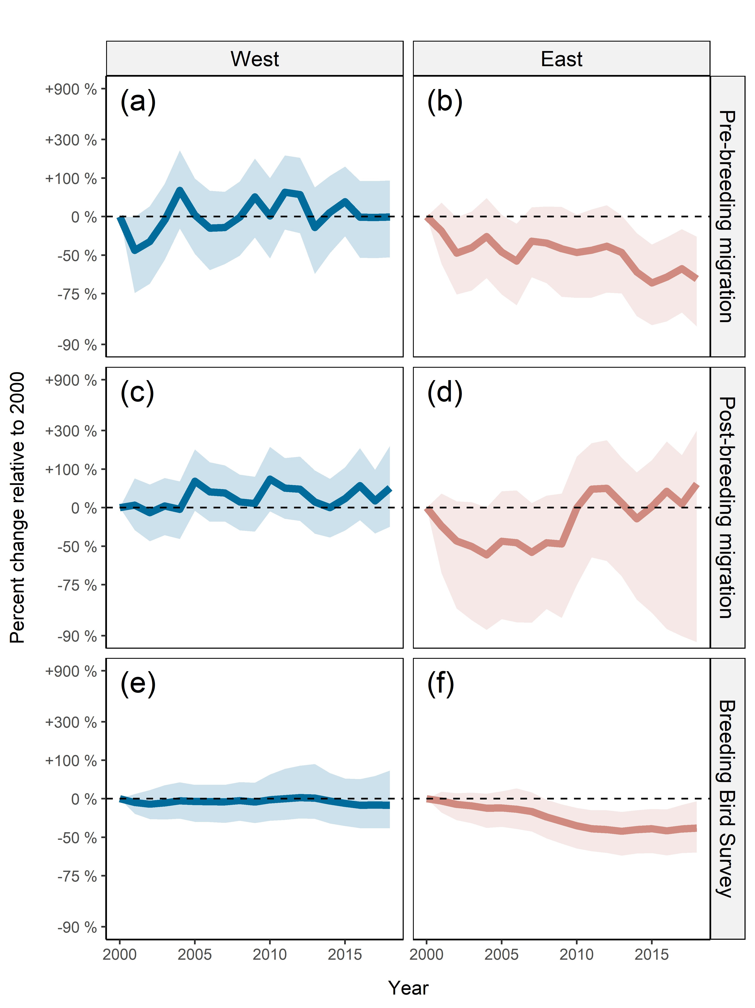

**Figure 2.** Estimated population trajectories of Blackpoll Warbler in East and West strata from 2000 to 2018, based on analysis of pre-breeding migration (a, b), post-breeding migration (c, d), and North American Breeding Bird Survey (e, f). Strata boundaries are illustrated in Figure 1.